VR Series

Strong and compact The ideal solution for highly demanding applications. Top Lifting class cranes with unlimited rotation during operation, space saving when not in use. Knuckle Telescopic boom and foldable Articulated Foldable boom cranes with slewing bearing rotation system and double linkage.

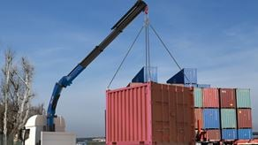

VR26NG

Max. Lifting capacity (kg)

5795

Lifting Moment Class (tm)

21

Max. Extension reach (m)

22.24

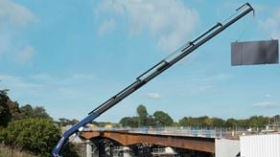

VR41NG

Max. Lifting capacity (kg)

0

Lifting Moment Class (tm)

0

Max. Extension reach (m)

0

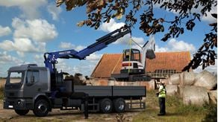

VR44NG

Max. Lifting capacity (kg)

0

Lifting Moment Class (tm)

0

Max. Extension reach (m)

0

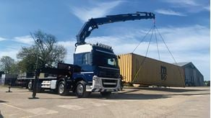

VR60NG

Max. Lifting capacity (kg)

57480

Lifting Moment Class (tm)

60

Max. Extension reach (m)

22.9

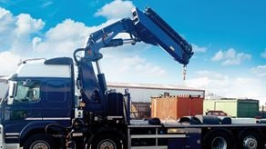

VR66NG

Max. Lifting capacity (kg)

63280

Lifting Moment Class (tm)

66

Max. Extension reach (m)

22.9



VR680NG

Max. Lifting capacity (kg)

0

Lifting Moment Class (tm)

0

Max. Extension reach (m)

0

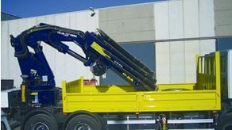

VR85

Max. Lifting capacity (kg)

17100

Lifting Moment Class (tm)

90

Max. Extension reach (m)

29.5